Software Requirements Specification

*for*

Travel Advisor Platform

**Version** 1.0 under Review

**Prepared By** Aya Ahmed

**Creation Date:** 4/12/20222

**Table of Contents**

**Introduction** **3**

Purpose 3

Document Conventions 3

Intended Audience 3

Project Scope 3

References 3

**Overall Description** **3**

Product Perspective 3

Product Features 4

Operating Environment 4

Design and Implementation Constraints 4

User Documentation 4

Assumptions and Dependencies 4

**System Features [Functional Requirements]** **5**

**External Interface Requirements** **6**

4.1 User Interfaces 6

4.2 Hardware Interfaces 8

4.3 Software Interfaces 8

**Nonfunctional Requirements** **8**

Performance Requirements 8

Safety Requirements 8

Security Requirements 8

Software Quality Attributes 9

**Other Requirements** **9**

**Revision History**

|  |  |  |  |
| --- | --- | --- | --- |
| **Name** | **Date** | **Reason For Changes** | **Version** |
| Aya | 14/4/2022 | Requirements need more details | 1.0 |
| Saad |  |  |  |

# Introduction

## Purpose

The purpose of this document is to present a detailed description of the Travel Advisor System which will guide the user of the system to view and travel to different destinations. It will explain the features of the system, interfaces of the system, what the system will do, the constraints under which it must operate.

This is 1.00 version of the system

## Document Conventions

NA

## Intended Audience

This document is intended for both the stakeholders and the developers of the system.

## Project Scope

The Travel Advisor System is a web-based application for managing Tourism which helps the customers to view various places along with the different packages available with the reservations.

This project also covers various features like online sginup of the users, adding details of the tours and their package information by the administrator of the website.

## References

* User requirements

# Overall Description

## Product Perspective

Travel Advisor Web Application is a new self-contained shell that covers all the major aspects in the computerization of a tourism agency. Some tasks are described in detail. User can enjoy sightseeing tours to any of the places, listed in Agencies Data File. Before that, the Customer has to make the booking by sginup in the Data-File and informing .

**Booking:**

User can also book a flight

**Ratings:**

A rating E-mail is sent to the user after returning from the tour

**Admin:**

Administration, which is responsible for adding destinations, new admins, setting budget and creating users.

## Product Features

**Customer:**

The one who uses the system. For which the system is created.

**Administrator:**

The one who operates the system, adds users or other admins, tours and their packages records in databases.

## Operating Environment

**Browsers:** Chrome, Firefox and Edge.

**Operating System:** Win 7, XP, Vista, 8, 10, 11

**Recommended Conf.:** 256mb RAM or higher, 10mb Disk space

**Screen Resolution:** 1024x768

## Design and Implementation Constraints

* *Web-based system*
* *Unique user IDs*
* *Admin feature needed*

## User Documentation

*N/A*

## Assumptions and Dependencies

* we are developing using c#
* Browsers: Chrome, Firefox and Edge.
* Operating System: Win 7,XP, Vista, 8, 10, 11
* Recommended Conf.: 256mb RAM or higher, 10mb Disk space
* Screen Resolution: 1024x768

# System Features [Functional Requirements]

*The System requirements are:*

This subsection contains the requirements for the Travel Advisor Platform. These requirements are organized by the features sequence to best capture the functional requirements of the system. All these functional requirements can be traced using a traceability matrix.

* 1. **Functional Requirements**

**3.1.1 User Requirements**

1. **Login:**

**REQ-01-User_Login:**Login page should contain two text boxes (the username and password fields) and two buttons (login button and sign up button) and one check box (admin checkbox).

**REQ-02-User_Login:**The username field should only accept English letters or a combination of English letters and numbers.

**REQ-03-User_Login**: password field takes a text of at least eight character text and it allows special characters and numbers too.

**REQ-04-User_Login**: when user press login button it checks the data into the text boxes based on REQ-02-User_Login & REQ-03-User_Login then checks if the username and password are already stored in the data base then the user is navigated to the home page*.*

**REQ-05-User_Login:**if the username or password are not written based on REQ-02-User_Login & REQ-03-User_Login an error message appear with “please insert data based on the required format”.

**REQ-06-User_Login:**if the username or password are not found in the database an error message appear with message “Please create an account first and then login”.

**REQ-07-User_Login:**if sign up button pressed the system navigates to the signing up page.

1. **Sign up:**

**REQ-01-Signup:** The sign up page should contains five text fields (Email, Mobile number, Age, Password, and Confirm Password) and two buttons (Sign up and Reset).

**REQ-02-Signup:** All the fields are required to make a valid signing up if any field is left empty a suited error message should appear on the screen.

**REQ-03-Signup:** Email field should contain a valid mail format as ([example@example.com](mailto:example@example.com)). It can be a combination of numbers and some special characters _,# as long as it is acceptable by the format.

**REQ-04-Signup:** Mobile field only accepts 11 number which should start with 01.

**REQ-05-Signup:** Age should only accept numbers between 18 and 90.

**REQ-06-Signup:** password & confirm password fields take a text of at least eight character text and it allows special characters and numbers too.

**REQ-07-Signup:** the password and confirm password should contain the same text (the text in this case is case sensitive).

**REQ-08-Signup:** when the user press the reset button all the fields should be empty.

**REQ-09-Signup:** when the user press sign up button and the fields apply to requirements (REQ-02-Signup, REQ-03-Signup, REQ-04-Signup, REQ-05-Signup, REQ-06-Signup, and REQ-07-Signup) the user data should be stored in its place in database, a unique UID should be generated and the user is navigated to the login page.

**REQ-10-Signup:** when the user press sign up button if any field doesn’t match with the required formats referred to then a suited error message should appear.

1. **Home Page:**

**REQ-01-Home:** when the user login successfully he will be directed to the home page that has a photo gallery of the different tours available should be displayed in the middle of the page also it shall contain a horizontal slider to help navigate throw the tours.

**REQ-02-Home:** the photo gallery should be sorted from the highest rating to the lowest.

**REQ-03-Home:** there should be a view button in every tour available so user can view the trip details.

1. **Tour details:**

**REQ-01-Tour:** the tour page should contain an image or many images for the place and a book button and description of the trip (name of the tour, Country name, duration, and cost) it also should contain a rating section and feedback (rating is 5-star based) it also should contain a video of the destination and a contact us button.

**REQ-02-Tour:** when the user press the book button a confirmation message appear on the screen if user press confirm a mail is sent to the user to confirm his booking to the tour (do not need a reply on mail to confirm booking) & user gets redirected to a thank you page then redirected to the home page after 3 seconds.

**REQ-03-Tour:** user can only rate or give feedback to tours that he had already done.

**REQ-04-Tour:** Feedback and rating are added in the database and then appear in the tour page.

**REQ-05-Tour:** when the contact us button is clicked it navigates to the footer containing the contacts of the company.

* + 1. **Admin Requirements:**

1. **Login:**

******Please note that it is the same login page mentioned above******

**REQ-01-Admin_Login:**Login page should contain two text boxes (the username and password fields) and two buttons (login button and sign up button) and checkbox (Admin) describing if it is a user or an admin.

**REQ-02-Admin_Login:**The username field should only accept English letters or a combination of English letters and numbers.

**REQ-03-Admin_Login**: password field takes a text of at least eight character text and it allows special characters and numbers too.

**REQ-04-Admin_Login:** when the check box is checked by the admin the system searches for the username and password in the admin table not user and the register button is disabled.

**REQ-05-Admin_Login**: when user press login button it checks the data into the text boxes based on REQ-02-Admin_Login & REQ-03-Admin_Login and admin check box is checked then checks if the username and password are already stored in the data base then the admin is navigated to the home page*.*

**REQ-06-Admin_Login:**if the username or password are not written based on REQ-02-User_Login & REQ-03-User_Login an error message appear with “please insert data based on the required format”.

**REQ-07-Admin_Login:**if the username or password are not found in the database an error message appear with message “username or password are not written correctly”.

1. **Add Admin**

**REQ-01-Add_Admin**: Admins cannot sign up like normal user but Admin has the ability to add another admin by clicking on add admin button available in the admin panel.

**REQ-02-Add_Admin**: the add admin page contains of four field (name, email, password, and confirm password) and two buttons (add and reset).

**REQ-03-Add_Admin:** The name field should only accept English letters or a combination of English letters and numbers.

**REQ-04-Add_Admin:** Email field should contain a valid mail format as ([example@example.com](mailto:example@example.com)). It can be a combination of numbers in and some special characters _,# as long as it is acceptable by the format.

**REQ-05-Add_Admin:** password & confirm password fields take a text of at least eight character text and it allows special characters and numbers too.

**REQ-06-Add_Admin:** the password and confirm password should contain the same text (the text in this case is case sensitive).

**REQ-07-Add_Admin:** All fields are require to add a new admin.

**REQ-08-Add_Admin:** if the data apply to the requirements (REQ-03-Add_Admin, REQ-04-Add_Admin, REQ-05-Add_Admin, and REQ-06-Add_Admin) then the data should be added in database and the system must generate a unique id for the admin.

**REQ-09-Add_Admin:** if any of the data does not apply with its requirement mentioned above the proper error message should appear.

**REQ-10-Add_Admin**: if the reset button is pressed all the fields should be empty.

1. **Add User:**

**REQ-01-Add_User:** The Add user page should contains five text fields (Email, Mobile number, Age, Password, and Confirm Password) and two buttons (Add and Reset).

**REQ-02-Add_User:** All the fields are required to make a valid Adding.

**REQ-03-Add_User:** Email field should contain a valid mail format as ([example@example.com](mailto:example@example.com)). It can be a combination of numbers in and some special characters _,# as long as it is acceptable by the format.

**REQ-04-Add_User:** Mobile field only accepts 11 number which should start with 01.

**REQ-05-Add_User:** Age should only accept numbers between 18 and 90.

**REQ-06-Add_User:** password & confirm password fields take a text of at least eight character text and it allows special characters and numbers too.

**REQ-07-Add_User:** the password and confirm password should contain the same text (the text in this case is case sensitive).

**REQ-08-Add_User:** when the reset button is pressed all the fields should be empty.

**REQ-09-Add_User:** when the admin press add button and the fields apply to requirements (REQ-02-Add_User, REQ-03-Add_User, REQ-04-Add_User, REQ-05-Add_User, REQ-06-Add_User, and REQ-07-Add_User) the user data should be stored in its place in database, a unique UID should be generated and the admin is navigated to the add user page.

**REQ-10-Add_User:** when the admin press add button if any field does not match with the required formats referred to before then a suited error message should appear.

1. **Add Tour:**

**REQ-01-Add_Tour:** add tour page should contain two text boxes (Tour name, Cost) and one check box (Country name) and a button (add image) that allows the admin to add images to the trip and a button (add trip).

**REQ-02-Add_Tour:** the tour name field can only accept English characters and does not accept any special characters or numbers.

**REQ-03-Add_Tour:** cost field only accept numbers that at least is 1000.

**REQ-04-Add_Tour:** Country name is set to Egypt by default and the Admin should choose any country from the available list.

**REQ-05-Add_Tour:** when user press add image a window is opened so admin can add the images he wants to the trip.

**REQ-06-Add_Tour:** all the fields are required to successfully add a new tour.

**REQ-07-Add_Tour:** When admin press add trip button and the data in fields apply with requirements (REQ-02-Add_Tour, REQ-03-Add_Tour, REQ-04-Add_Tour, and REQ-05-Add_Tour) then the data is stored in the database and then be available for users to book it.

# External Interface Requirements

## 4.1 User Interfaces

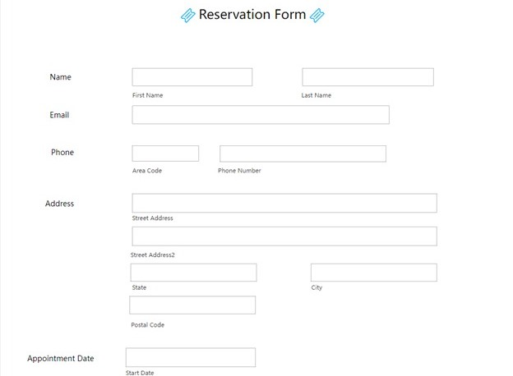

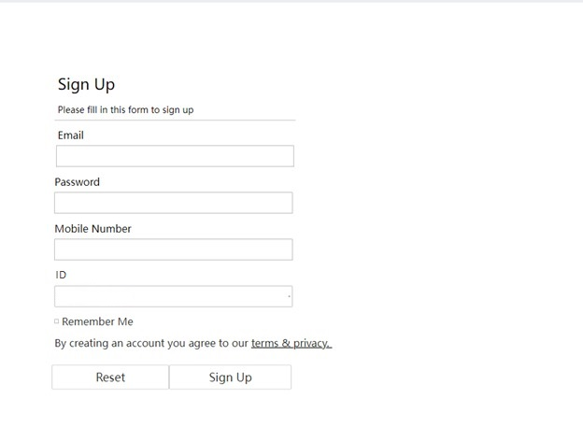

.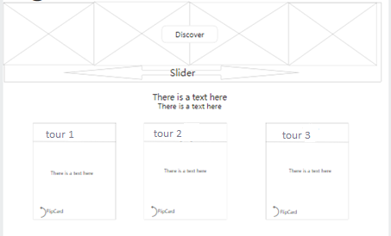

## 

## 4.2 Hardware Interfaces

* Processor : Pentium IV
* Speed : 2.0 GHZ above
* Hard Disk : 40 GB
* RAM : 512 MB
* CD Drive : 48x
* Input devices : Keyboard and mouse
* Monitor : Compatible monitor with 600 x 800 resolutions
* Internet : 100kbps above
* Printer : Any printer compatible for Windows

## 4.3 Software Interfaces

* Operating System : Windows 7 or Higher versions
* Front End : .NET
* Back End : SQL

# Nonfunctional Requirements

## Performance Requirements

The user should be able to login to the system using high speed internet. Most of the requests sent to the application should be answered in less than 20 seconds.

## Safety Requirements

NA

## Security Requirements

NA

## Software Quality Attributes

**Portable:**

Our product will be portable to carry and will run in any machine provided it runs a Windows Operating System.

**Transparent:**

Ideally, the user should not be aware that authentication is taking place beyond the requirement to enter a password.

# Other Requirements

NA

**Appendix A: Glossary**

3.1.1.6 UID: user identifier

**Appendix B: Analysis Models**

NA

**Appendix C: Issues List**

NA